**Project Structure**

* **Project Overview**

**Project Name:** Skill Swap – Learn & Teach Platform

**Description:** A modern web platform where users can share what they can teach and what they want to learn. A user can learn and teach on the same platform. The system matches users with others who can help them, making it easy to connect, share knowledge, and grow skills collaboratively.

**Target Audience:** Students, professionals, and hobbyists who want to learn and teach skills in an easy, friendly environment.

* **Functionalities**
* **Sign in/Sign** to manage profile, roles and skills.
* **Post a Skill -** User (Teacher) can post Skill to teach and Student can post skill which he wants to learn.
* **View Matches** with filtering options.
* **Flexible Criteria & Duration** - Users can set their own learning or teaching preferences, including custom skill categories, proficiency levels, cost , and availability, making it easy to create a schedule that works best for them.
* **Switch Themes** between light and dark mode.
* **View Profile Cards -** Users can browse and view each other’s profiles, whether they are a teacher, a student, or both.
* **Learn & Teach Simultaneously** – Users can be both learners and teachers.
* **Chat -** Enables real-time text-based communication between users within the application.
* **Website Pages Overview:**

**1. Home Page**

* Hero section (Learn, Teach, Swap Skills)
* Quick stats (Active users, Skills shared, Connections)
* Buttons to start learning or share skills

**2. Discover Page**

* Browse all available skills
* Search and filter by category, level, location, etc.
* Profile card previews (like your Emma/David example)

**3. Post Skill Page**

* Form to add a new teaching or learning skill
* Select category, level, duration, availability, tags

**4. My Skills Page**

* List of skills the user is teaching or learning
* Edit or delete posted skills
* Track pending requests

**5. Profile Page**

* User details (name, location, rating, bio)
* Skills they can teach / want to learn
* Button to request connection

**6. Notifications Page**

* Requests to learn or teach
* Accept/Decline buttons
* Updates on accepted or declined requests
* System announcements

**7. Chat / Messages Page**

* 1-on-1 messaging between connected users
* Send text, possibly links or files for lessons

**8. Login Page**

Email/password login or social sign-in

**9. Sign-Up Page**

Create account with required details

* **Website Work Flow:**

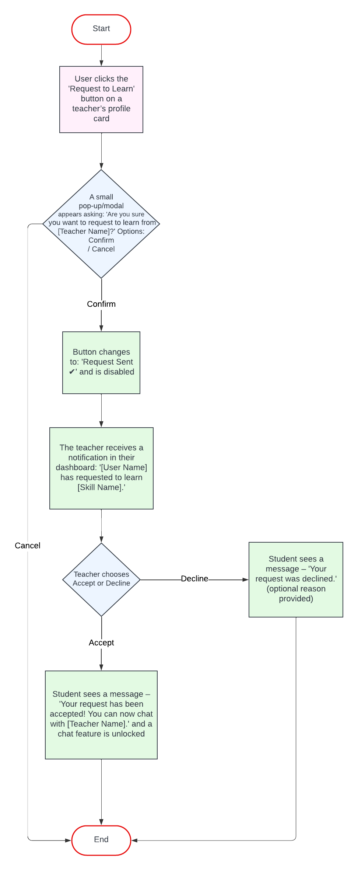

* **Website Users**

**Learners**

* People who want to acquire new skills.
* Can browse teachers, send learning requests, and join sessions.

**Teachers**

* + People who share their expertise.
  + Can receive learning requests, accept or decline them, and connect with learners.

**Dual-role Users**

* Users who both teach and learn different skills.
* Can post multiple skills they can teach and ones they want to learn.
* **Tools & Technology**

**Frontend:** React.js, HTML5, CSS3

**Backend:** Node.js, Express.js

**Database:** MongoDB

**Testing:** Jest, React Testing Library

**Version Control:** Git & GitHub

**Story Boarding:**

<https://skillswap-aesthetica-theme.lovable.app/>